Module Two Milestone

Michael Buxton

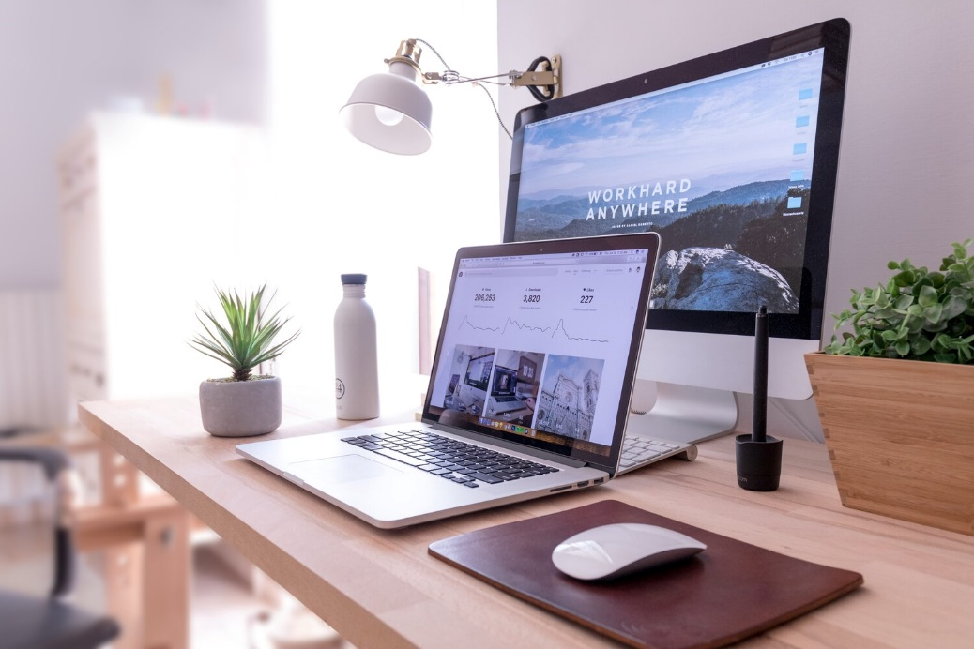

This is the picture that I have decided to recreate. I know a desk is probably used a lot but I figured it is where I spend most of my time and would incorporate a good combination of different shapes to complete all the items. The four objects that I will recreate in this scene will be both computers, the laptop as well as the desktop screen behind. I will then create the mouse, the mouse pad, and the water bottle on the left side of the desk.

To break down each of the objects that I will create in 3d, we will start with the plane that will be used as the desk and the flat surface to ground all of these objects. The laptop will be a combination different cubes and will have to be thin and size out for both the overall shape as well as the keys on the keyboard. The desktop will be a combination of a cube for the main screen a quarter of a sphere with another cube on the end to make the stand. The mouse could be a portion of a thin torus, while the mouse pad will be a plane as well. Lastly is where the other shapes will come into play as the water bottle will most likely have to be a cylinder with a sphere towards the top and a sort of upside down pyramid on top of that to complete the bottle. This is due to the different shape that is used towards the top of the bottle rounding off and then going back outwards to the top.

I believe these objects will give me something that is exciting to work through with the differences and shapes of the objects being used, as well as be challenging and achievable at the same time. The combinations that will be required for the desktop stand as well as the water bottle could be tough to complete but I am looking forward to creating this scene as a while.